2 1CY681– Internet Protocol lab

ASSIGNMENT -6 Name: Akhil K J

Register Number : CYS22009

Title: Understanding ARP using wireshark

Date of Assignment provided: 05/11/2022

Aim: To study about ARP request and response using wireshark.

IP LAB EXPERIMENT – 6 [CYS 2022 - 2024]

(Note: Total 25 marks for this lab assignment which includes 20 marks + 5 marks for your report)

**For each of the following steps, describe your results, give the syntax of the command you used, and, where appropriate, the output produced. Include screen captures as needed in your output. Be sure to label your results carefully and organize your results in the order of steps as given here and answer each question in your report.**

Use the provided pcap file (Arp) to answer the following questions.

1. Answer the following questions based on the contents of the Ethernet frame containing the HTTP GET message.
   1. What is the 48-bit Ethernet address of your computer?



* 1. What is the 48-bit destination address in the Ethernet frame?



Is this the Ethernet address of gaia.cs.umass.edu? What device has this as its Ethernet address?

No this is the address of the router

* 1. Give the hexadecimal value for the two-byte Frame type field. What upper layer protocol does this correspond to?



Hexadecimal valu:0x0800

Ipv4 Protocol

1. Answer the following questions based on the contents of the Ethernet frame containing the first byte of the HTTP response message.
   1. What is the value of the Ethernet source address?

Source Address: 00:06:da:af:73

* 1. What is the destination address in the Ethernet frame? Is this the Ethernet address of your computer?



* 1. Give the hexadecimal value for the two-byte Frame type field. What upper layer protocol does this correspond to?

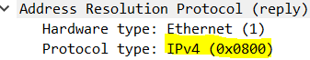

1. Answer the following questions based on the contents of the ARP Request packets.
   1. What are the hexadecimal values for the source and destination addresses in the Ethernet frame containing the ARP request message?



* 1. Give the hexadecimal value for the two-byte Ethernet Frame type field.

Protocol Type: Ipv4(0x0800)

* 1. How many bytes from the very beginning of the Ethernet frame does the ARP opcode field begin?

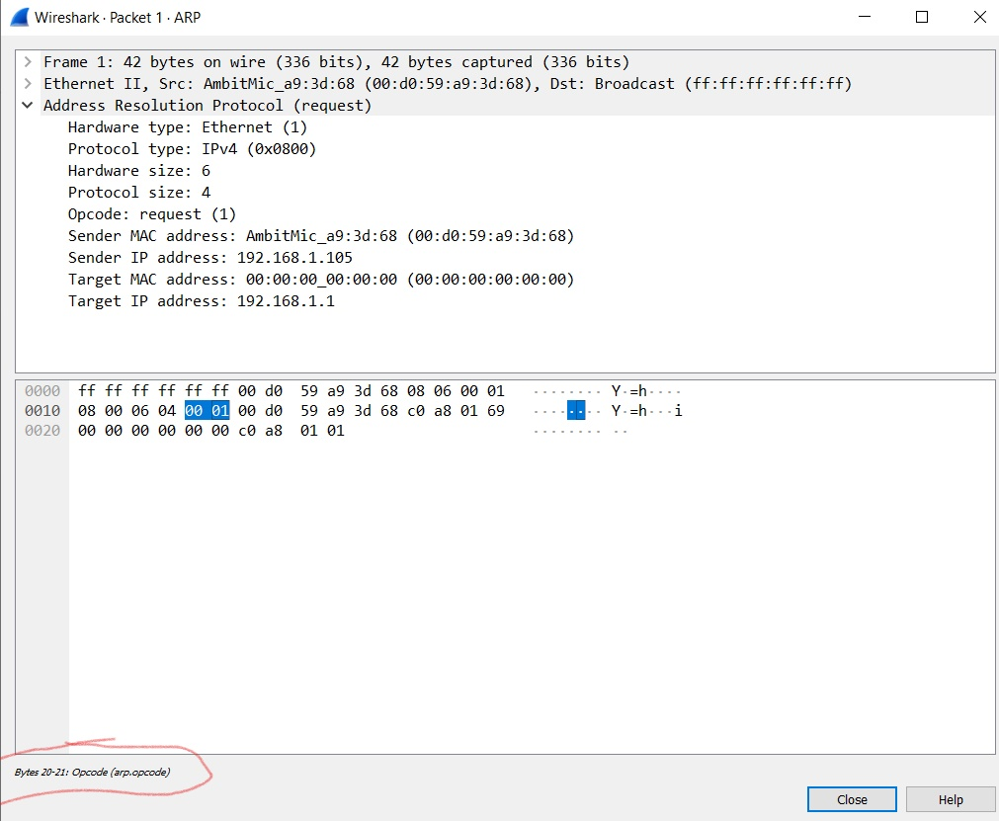

* 1. What is the value of the opcode field within the ARP-payload part of the Ethernet frame in which an ARP request is made?

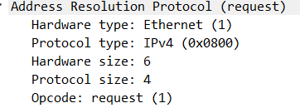

* 1. Does the ARP message contain the IP address of the sender?

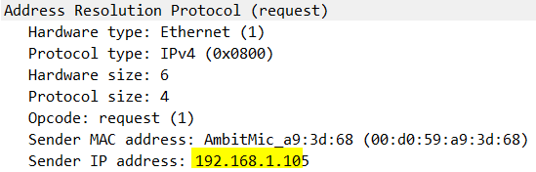

* 1. Where in the ARP request does the “question” appear – the Ethernet address of the machine whose corresponding IP address is being queried?
  2. 

1. Answer the following questions based on the contents of the ARP Reply packets.
   1. How many bytes from the very beginning of the Ethernet frame does the ARP opcode field begin?

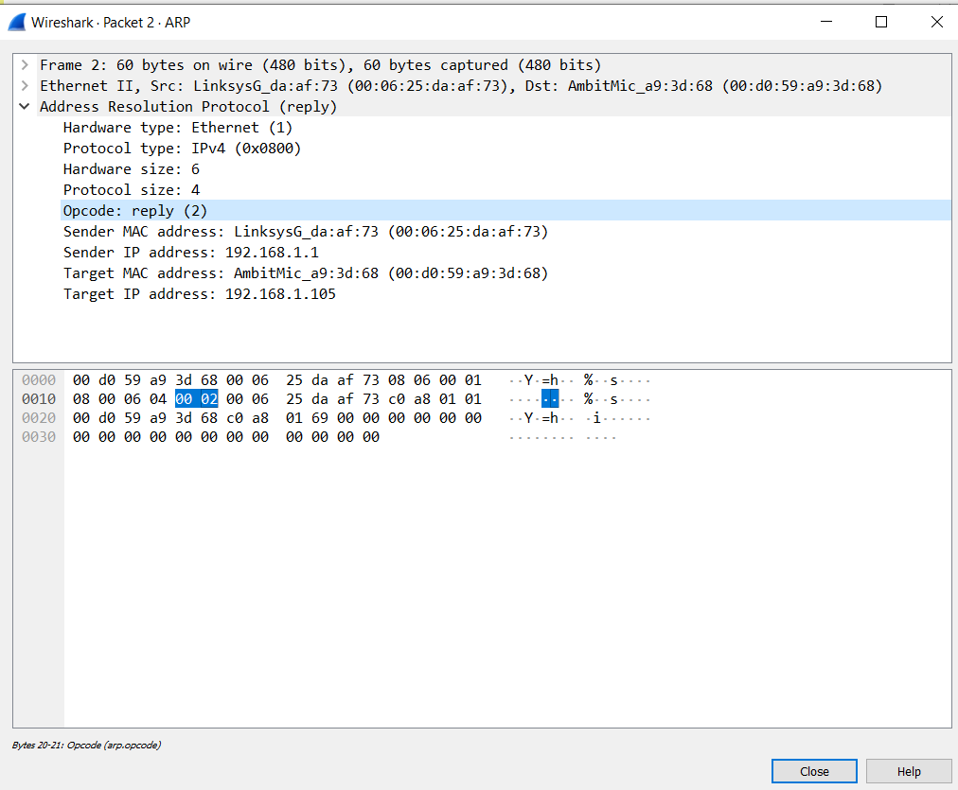

* 1. What is the value of the opcode field within the ARP-payload part of the Ethernet frame in which an ARP response is made?

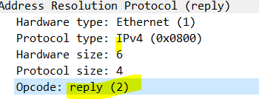

* 1. Where in the ARP message does the “answer” to the earlier ARP request appear – the IP address of the machine having the Ethernet address whose corresponding IP address is being queried?

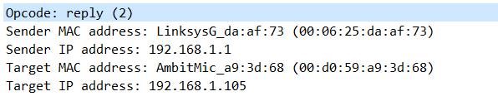

* 1. What are the hexadecimal values for the source and destination addresses in the Ethernet frame containing the ARP reply message?



* 1. There is yet another computer on this network, as indicated by packet 6 – another ARP request. Why is there no ARP reply (sent in response to the ARP request in packet 6) in the packet trace?

There is no response for the second ARP request packet because ARP request packet is a broadcast message and the arp response is unicast . So the computer which has the ip that is queried by the server will send a unicast response packet back to the router. So since the traffic is captured from this computer which has the ip .105 we are not able to see the reply arp packet which is sent back.